How to Support Your Mind
Caring for our mind is important. This is doubly true when we are working through a mental illness such as anxiety or depression. Our doctors and counselors can help us in many ways, but we are not powerless. How we care for our bodies, spend our time, and think drastically effects our mind. This handout is a tool for you to find a way to support your mind. We all like different things, so use this tool to find what works for you.
Go through the questions and try to commit to a small change that you can make today.
- Pick a resource you like from the back of this page

- Describe why it is important for you to make this change

- Describe the steps you can make today

- List three things that could interfere

- How important is this to you?
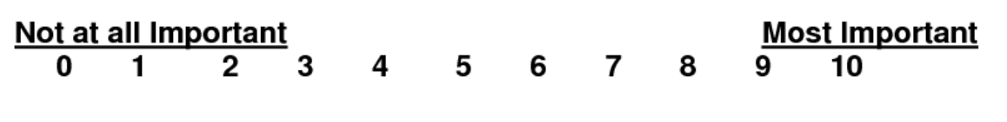
- How confident are you that this can and will be done?

Exercise:
Go for a walk for 5 minutes three times per day, maybe do this with a friend
Yoga – Moodra yoga in South Hero 16$/session
Gyms
- Planet fitness – cheapest option (St. Albans 802-582-4149, So. Burl 802-863-8910)
- Snap Fitness (802-891-6364)
- Ultimate Fitness (802-893-7811)
Your own idea!
Meditation and Mindfulness
- https://www.calm.com/ (free, website)
- https://www.headspace.com/ (5$/mo, phone app)
- https://insighttimer.com/ (free, phone app)
- https://www.youtube.com/user/TheHonestGuysGyms (youtube channel, free). You can also search youtube for something like “10 minute guided meditation,” and find one that works for you.
Getting Good Sleep (pick one maybe)
- Set a regular bed time, de-caffeinate, exercise, only use your bed for sleep, reduce screen time before bed or set them to night mode.
- CBT-I Coach App: https://itunes.apple.com/us/app/cbt-i-coach/id655918660?mt=8
Other
- Reach out and connect with friends or family
- Get a pet! Animals can be great friends and be healthy for your mind.
- Anxiety Meetup Group meets monthly near Hinesburg, VT
https://www.meetup.com/Anixety-Meetup/
- The Pathways Vermont Community Center Meetup Group
https://www.meetup.com/The-Pathways-Vermont-Community-Center
“Adults looking for peer-to-peer connection and mental health support, help with the employment search, community, groups, and a welcoming and resourceful space! Everything in the center is FREE.”
- Nutrition Book: Nutrition Essentials for Mental Health: A Complete Guide to the Food-Mood Connection

